|  |  |
| --- | --- |
| **Databases**  Diploma in IT / FI / CSF  Year 1 (2019/20) Semester 2 | Week **5** |
| **2** hours |
| **PRACTICAL 5**  **SELECT (Part 5)** | |

**OBJECTIVES**

At the end of this practical, you should know how to:

* construct SQL queries that group rows that have the same values for certain columns
* construct SubQuery in SELECT statement

**REFERENCES**

Please refer to the following appendices in Database textbook.

* Appendix B: Tables in NP40 Book Rental System’s Database
* Appendix E: Data Dictionary for NP40 Book Rental System
* Database Textbook: pages 2-43 to 2-49 and 2-58 to 2-64
* PolyMall: Database Systems - [Topic 4 Group By](https://polymall.polytechnic.edu.sg/webapps/blackboard/content/listContentEditable.jsp?content_id=_30618_1&course_id=_813_1&mode=reset&courseTocLabel=Topic+4+Group+By)
* PolyMall: Database Systems - Topic 5 Join

[5.2 Join Tables and Group By](https://polymall.polytechnic.edu.sg/webapps/scor-scormengine-BB5784d4c32fccb/delivery?action=launchPackage&course_id=_813_1&content_id=_36379_1)

* PolyMall: Database Systems - Topic 6 Subqueries

[6.1 Single-Row Sub-Query](https://polymall.polytechnic.edu.sg/webapps/scor-scormengine-BB5784d4c32fccb/delivery?action=launchPackage&course_id=_813_1&content_id=_36380_1)

[6.2 Multi-Row Subquery – Part 1](https://polymall.polytechnic.edu.sg/webapps/scor-scormengine-BB5784d4c32fccb/delivery?action=launchPackage&course_id=_813_1&content_id=_30635_1)

Syntax:

**SELECT [ ALL | DISTINCT ] { \***

**| { table_name | table_alias }.\***

**| { column_name | express } [ [ AS ] column_alias ]**

**| column_alias = expression**

**} [ , … n ]**

**FROM table_name1 [ [ AS ] table_alias ]**

**[ INNER JOIN** **table_name2** **ON** *table_name1.field1* = *table_name2.field2* **]**

**[ INNER JOIN** **table_name3** **ON** *table_name2.field2* = *table_name3.field3* **]**

**[ INNER JOIN** **table_namex** **ON** *table_name3.field3* = *table_namex.fieldx* **]**

**[ WHERE search_condition ]**

**[ GROUP BY** **column {, column} ]**

**[ HAVING** **search_condition ]**

**[ ORDER BY { order_expression [ ASC | DESC ] } [ , … n ] ]**

**QUESTIONS**

Construct SQL statements for the following queries.

### GROUP BY 1 column

1. List the number of members for each branch. Display the results as shown below:

BranchNo Number of Members

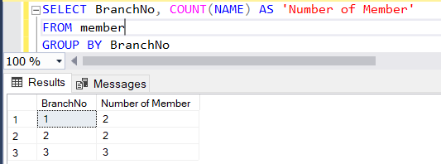

(Hint: use GROUP BY clause to group rows.)

Note: Besides the Aggregate value in the SELECT clause, only the column(s) in the GROUP BY clause may be specified in the SELECT clause.

1. List the number of copies for each book in descending order of number of copies. Display the results as shown below:

ISBN Number of Copies

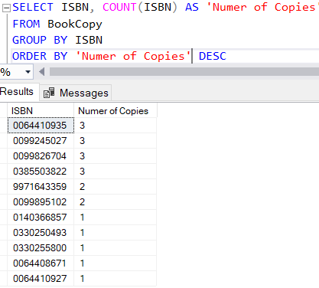

1. List the number of copies for each book that have more than 2 copies. Display the results as shown below:

ISBN Number of Copies

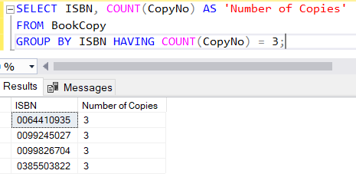

(Hint: use GROUP BY and HAVING)

##### **GROUP BY 2 columns**

1. For each book category, compute the number of books published by each publisher. Display the results as shown below:

BookCat PublisherID Number of Books

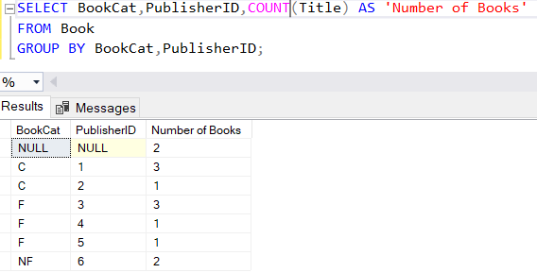

5. For each branch, compute the number of female staffs supervised by each supervisor. Display the results as shown below.

BranchNo SupervisorID Number of Female Staffs

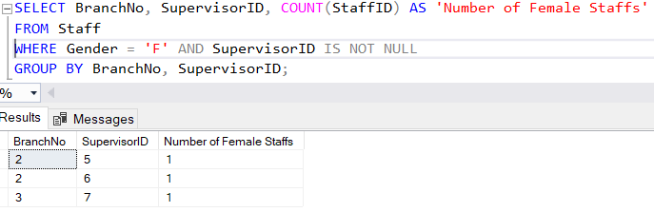

(Hint: use GROUP BY and WHERE)

##### **GROUP BY AND INNER JOIN**

6. List each publisher in NP40 Book and the number of book it published. Display the results in descending order of number of book published by each publisher.

Publisher Number of Book

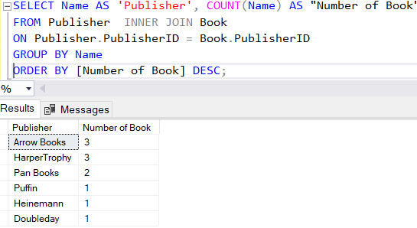

(Hint: Use INNER JOIN and GROUP BY in your answer.)

**SUBQUERIES**

7. Construct a SELECT statement with subquery to list the ISBN, copy number, date of loan for the loans made by the member named 'Kumar'.

ISBN CopyNo DateOut

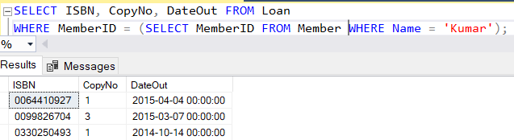

(Hint: The details to be retrieved are from the *Loan* table but you are requested to retrieve the loan made by 'Kumar' – member’s name that can only be found in the *Member* table.)

8. Construct a SELECT statement with subquery to list the title and year publish of the books that have at least a copy.

Title YearPublish

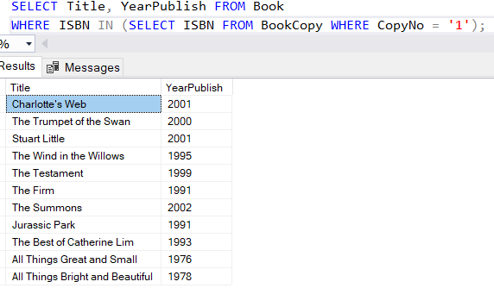

9. Construct a SELECT statement with subquery to list the ISBN and title of books that have not been loaned out before.

ISBN Title

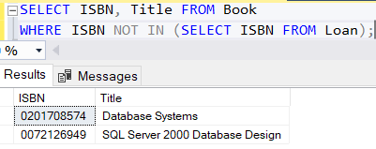

10. Construct a SELECT statement with subquery to list name and salary of staff who has the highest salary.

Name Salary

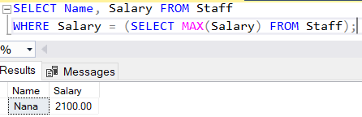

(Hint: Use Aggregate function MAX().)

11. Construct a SELECT statement with subquery to list member id, name and gender of members who have made more than 5 loans.

MemberID Name Gender

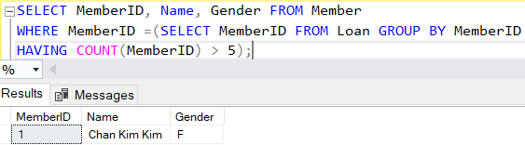

(Hint: Use Aggregate function Count().)

**Point to Ponder**

Can you use the “=” operator instead of the “IN” operator for the Subquery?

12. Rewrite Practical 4 Question 8 using a subquery.

List the names of all the supervisors in alphabetical order. If the supervisor has more than one staff, his name should appear only once.

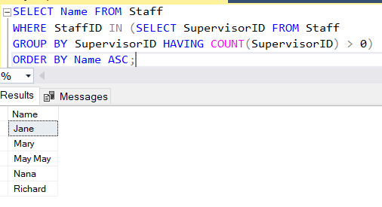

13. Is it possible to rewrite the subquery for Question 10 using a join? Explain.

Yes, you can do a sub query using ‘join’

**Quick Recap**

Practical 1 – Basic Select Statement (DISTINCT, AS, ORDER BY)

Practical 2 – Row Selection using WHERE

Practical 3 – Functions (Date, String, Aggregate)

Practical 4 – Inner Joins with multiple tables

Practical 5 – Group By and Having, Subqueries

**What’s next?**

We have been doing SELECT for our SQL statements for the first 5 practical.

Moving on, we will look at how we will be inserting, updating and deleting data in the database.

**Optional**

14. List the branche(s) that have 3 or more members. Display the results as shown below:

BranchNo Number of Members

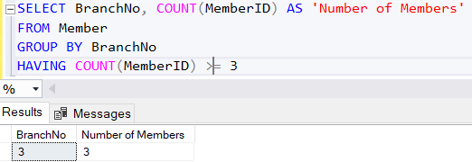

(Hint: use GROUP BY and HAVING)

15. For each branch, compute the number of members for each gender. Display the results as shown below:

BranchNo Gender Number of Members

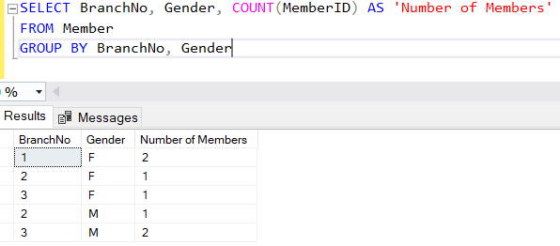

16. List author and the number of books written by the author. Display the results in descending order of number of book written by the author.

Author Number of Book

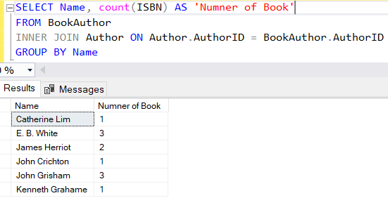

17. Construct a SELECT statement with subquery to list the loanNo, isbn and date of loan for the loans made by member from branch number 1. Display the results in the order of earliest to the most recent date of loan.

LoanNo ISBN DateOut

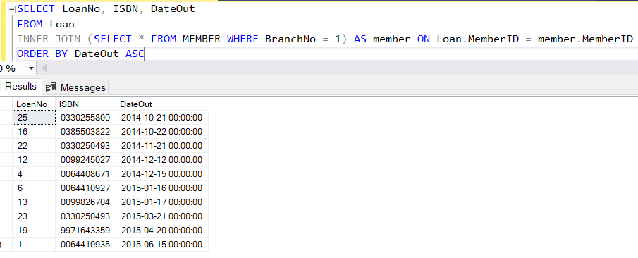

18. For each branch, compute the number of staffs by gender supervised by each supervisor. Display the results as shown below.

BranchNo SupervisorID Gender Number of Staff

